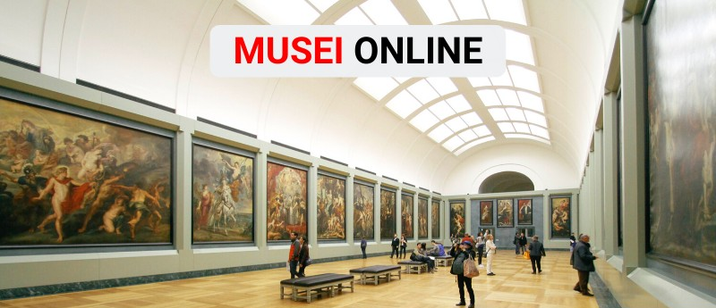
Dieci musei da visitare stando a casa: tour virtuali e collezioni online
1. Pinacoteca di Brera - Milano https://pinacotecabrera.org/
2. Galleria degli Uffizi - Firenze https://www.uffizi.it/mostre-virtuali
3. Musei Vaticani - Roma http://www.museivaticani.va/content/museivaticani/it/collezioni/catalogo-online.html
4. Museo Archeologico - Atene https://www.namuseum.gr/en/collections/
5. Prado - Madrid https://www.museodelprado.es/en/the-collection/art-works
6. Louvre - Parigi https://www.louvre.fr/en/visites-en-ligne
7. British Museum - Londra https://www.britishmuseum.org/collection
8. Metropolitan Museum - New York https://artsandculture.google.com/explore
9. Hermitage - San Pietroburgo https://bit.ly/3cJHdnj
10. National Gallery of art - Washington https://www.nga.gov/index.html

